For Immediate Release:
October 20, 2017

Welcome to the Play Room: a Solo Exhibition by Andy Malone

A selection of games and interactive artwork by Andy Malone will be featured in a solo exhibition entitled “Play Room” at the Collective Art Gallery in Detroit, Michigan. The exhibition opens Saturday November 11, 2017. Andy is a nationally recognized artist who is known for his automata, abstract games, animations and collaborative art-making mechanisms. All pieces are intended to be physically manipulated by the viewer.

Andy Malone is an artist from Detroit, Michigan. His work has been featured in over 60 exhibitions around the United States. He was recently featured in Essay’d and was invited to demonstrate his collaborative art making machines at the Detroit Institute of Arts. Regarding his work, Andy stated: “My work requires the viewer to physically engage with it to complete its purpose. By erasing the boundary between the art and viewer I invite people to look at the world in a new way.”
Visit www.andymalone.com for additional information, contact info and images.

Located on Jefferson Ave in beautiful Indian Village, The Collective is a hub for arts and culture. In addition to the gallery, The Collective is home to an amazing team of businesses and artists.

Play Room
Interactive Art and Games by Andy Malone
Opening Reception November 11, 2017 4-8PM
November 11-25, 2017 (by appointment only)

The Collective
8325 Jefferson
Detroit MI, 48214
(313) 477-0222

www.andymalone.com
andymalone@gmail.com
www.thecollectivedetroit.com

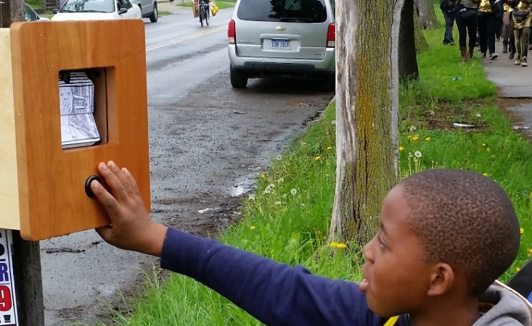

“Gramma Loves You” Mutoscope at the Porous Borders Festival, 2015

